**COST:**

|  |  |  |  |
| --- | --- | --- | --- |
| DESCRIPTION | DESCRIPTION | LINK | COST / PERSON |
| Airticket /person | 23 - 27 OCT | [tickets](https://www.skyscanner.com.sg/transport/flights/sin/tjq/191023/191027/?adults=1&children=0&adultsv2=1&childrenv2=&infants=0&cabinclass=economy&rtn=1&preferdirects=false&outboundaltsenabled=false&inboundaltsenabled=false&ref=home#/) | 250 |
| Grand Hatika Hotel  BW Suite Belitung | 23 -25 OCT ($93.58 for 2)  25 - 27 OCT ($177.02 for 2) | Hotel | 135.30 |
| Activities | For 3 day $80/day |  | 240 |
| Food | 15/meal X 10 |  | 150 |
| Transport | 20/day X 5 |  | 100 |
| Insurance |  |  | 20 |
|  |  |  |  |
|  |  |  |  |

**AIRTICKETS:**

|  |  |  |  |  |
| --- | --- | --- | --- | --- |
| **Final Cost** | **Date, Time** | **Location** | **Airline** | **Booking No** |
| $130 for 2 | 23/10 , 0745 to 0850 | SING - KL | AIRASIA - AK 700 | GRRHTF |
| $119.16 for 2 | 23/10, 1105 to 1145 | KL - TJQ | AIRASIA - QZ 246 | OZ4C2G |
| $164.58 for 2 | 27/10, 1820 to 1920 | TJQ - CGK | AIRASIA - QZ 713 | R3R8SA |
| $85.45 for 2 | 27/10, 2155 to 0045 | CGK - SIN | JETSTAR - 3K 206 | MKJ2VD |

**TOTAL COST: $500 for 2**

**SELF HYPE VIDEOS / ARTICLES:**

<https://www.youtube.com/watch?v=lFlvceyvcHc>

<https://www.channelnewsasia.com/news/asia/belitung-island-beach-holiday-vacation-destination-10980736>

**HOTEL**

Suggestions: Eco Beach Tent by Billiton - $368

|  |  |  |  |
| --- | --- | --- | --- |
| Hotel | [Havana Mutiara Hotel Belitun](https://www.agoda.com/en-sg/havana-mutiara-belitung/hotel/belitung-id.html?checkin=2019-10-25&los=2&adults=2&rooms=1&cid=-1&searchrequestid=3b10560e-e937-4731-babd-6f0c010c2566&travellerType=-1&tspTypes=2&tabbed=true)g | [BW Suite Belitung](https://www.agoda.com/en-sg/bw-suite-belitung/hotel/belitung-id.html?checkin=2019-10-23&los=2&adults=2&rooms=1&cid=-218&searchrequestid=e8951bff-274d-42b7-a73f-15251d1074ff&travellerType=1&tabbed=true) | [Grand Hatika Hotel](https://www.expedia.com.sg/Tanjung-Pandan-Hotels-Grand-Hatika-Hotel.h9627280.Hotel-Information?chkin=25%2F10%2F2019&chkout=27%2F10%2F2019&regionId=3451&destination=Tanjung+Pandan%2C+Bangka+Belitung+Islands%2C+Indonesia&swpToggleOn=true&selected=9627280&rm1=a2&x_pwa=1&sort=recommended&top_dp=34&top_cur=SGD&rfrr=HSR&pwa_ts=1568221067223) |
| Cost | $ 28/night | $ 57/night | $ 39/night |
| Photos |  |  |  |
| Amenities | No Pool | Fitness center  Swimming pool [outdoor]  Breakfast [free]  Snooker table | Pool |
| Nearest Attraction | Tanjung Pandan Museum 482m walk | Tanjung Pandan Beach 15mins walk | Tanjung Pandan Beach 1 min walk |

Grand Hatika Hotel

Check-in : Wednesday, 23 Oct,2019 (2.00PM)

Check-out : Friday, 25 October 2019 (Noon)

BW Suite Belitung

Check-in : Friday, 25 October 2019 (11AM -12PM)

Check-out : Sunday, 27 October 2019

Stay : 2 nights, 1 room, 2 adults

**PLACES TO VISIT:**

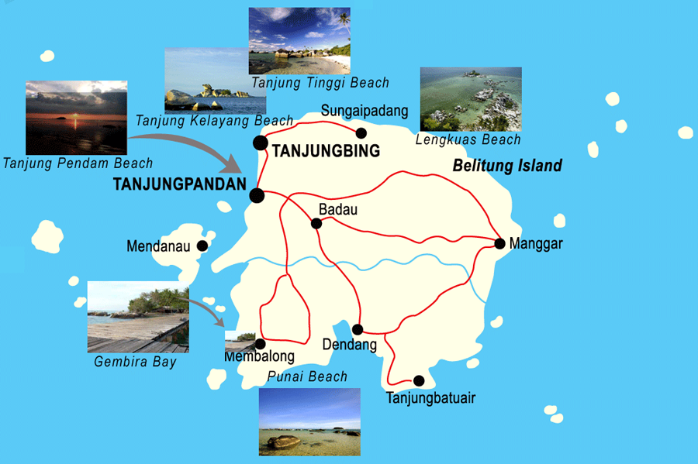

Leebong Sand Island

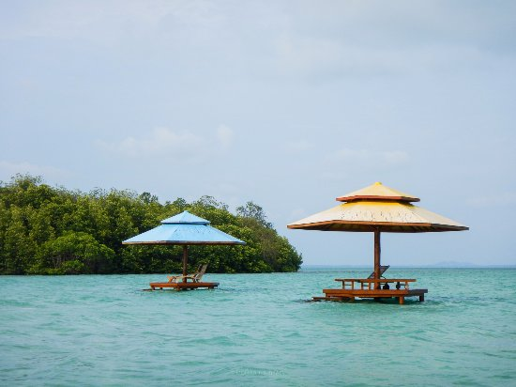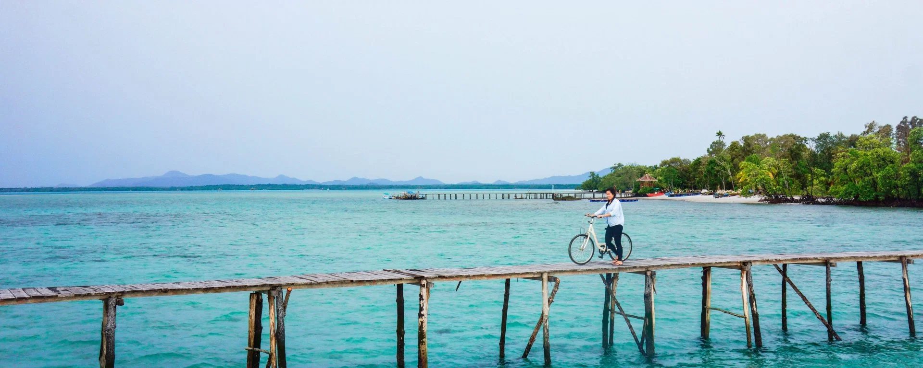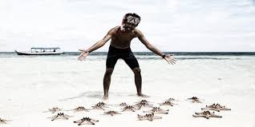

Tin Mine Open Pit - Kik Karak Hill

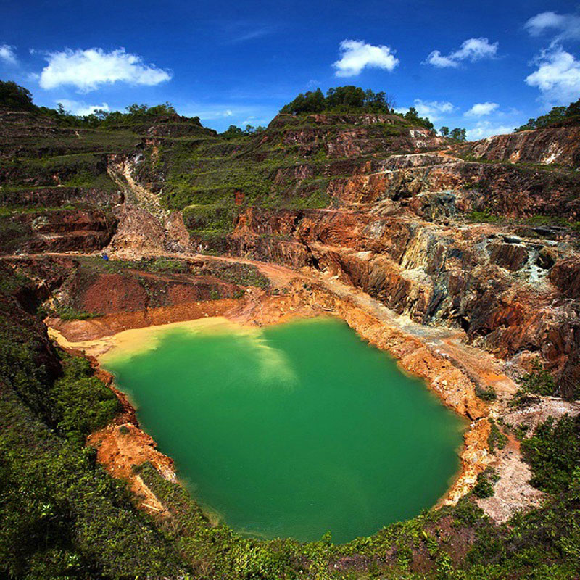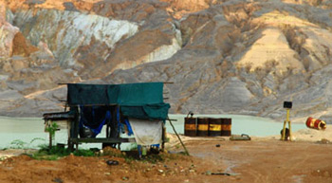

Pantai Serdang

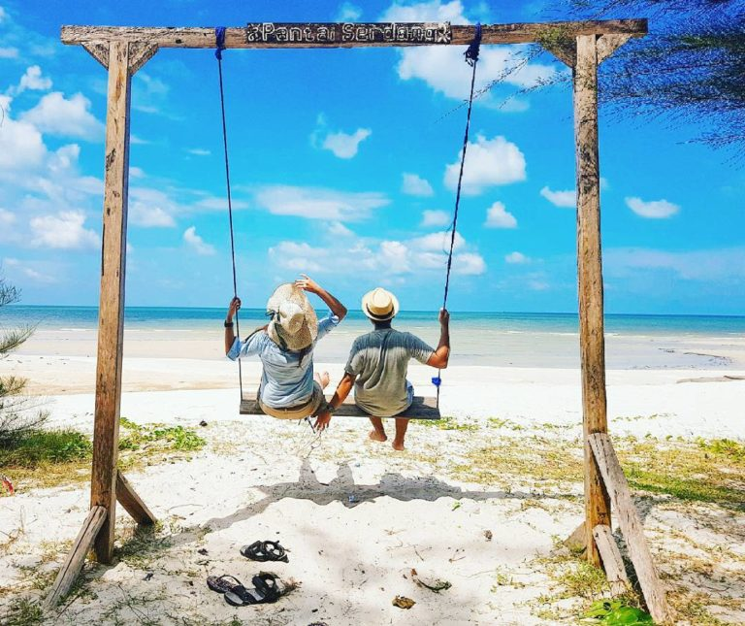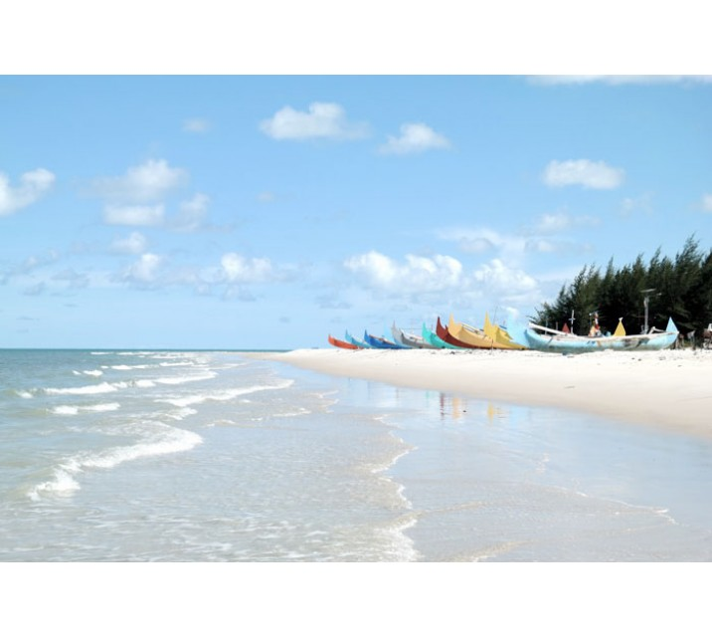

Tanjung Tinggi

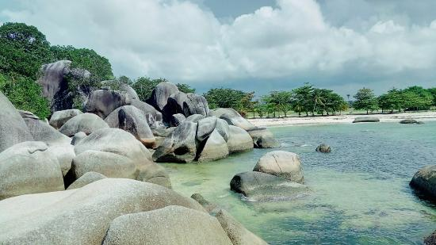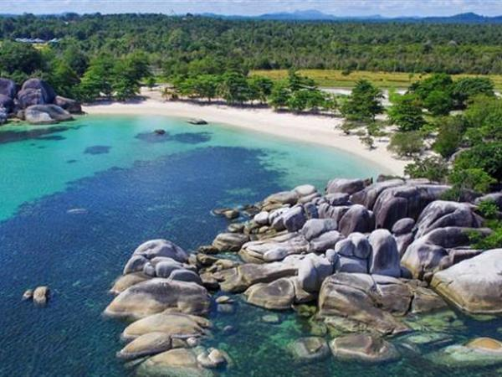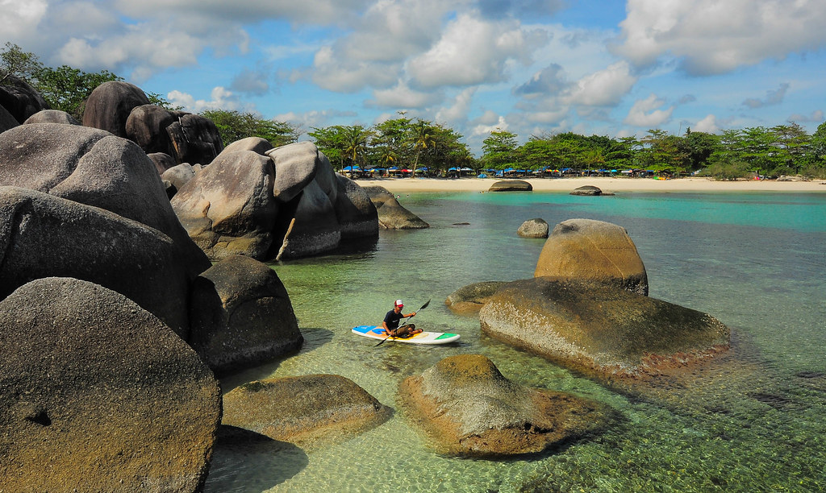

Pulau Memperak

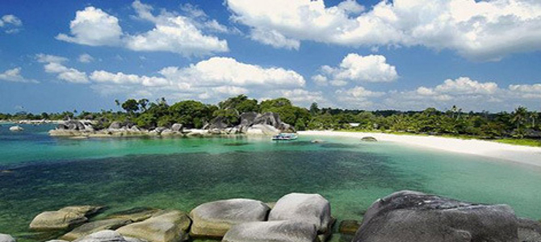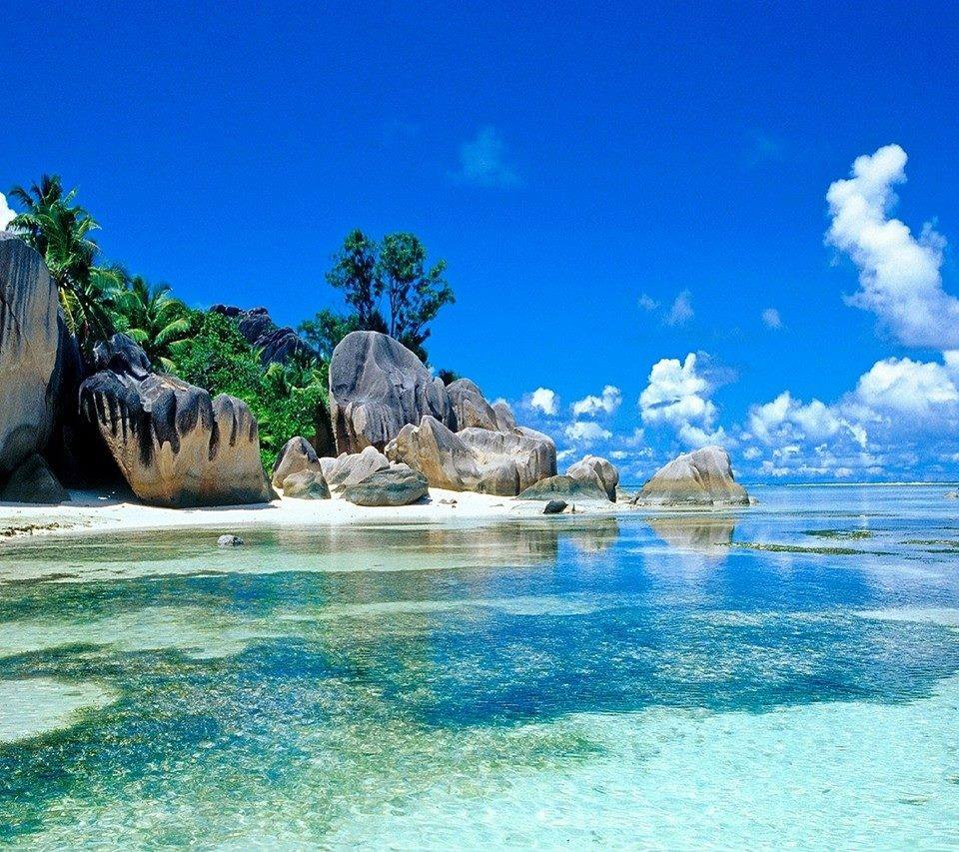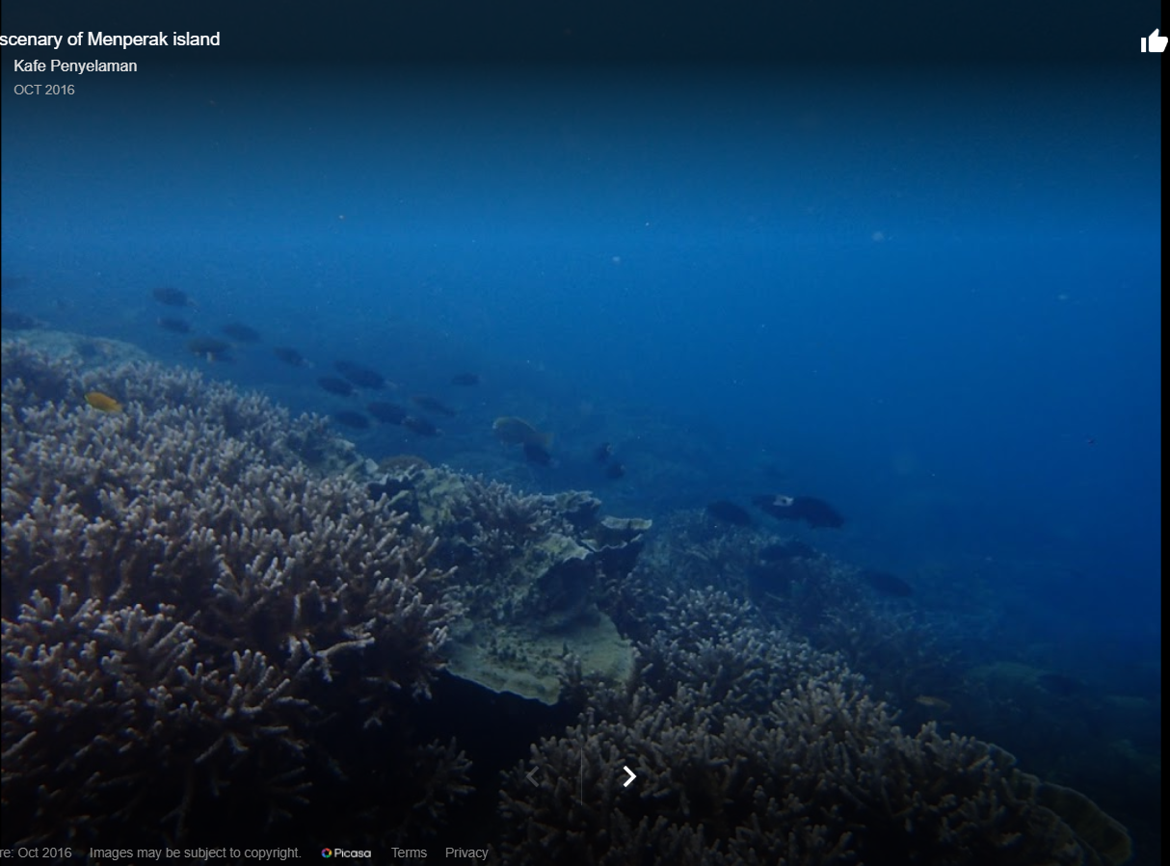

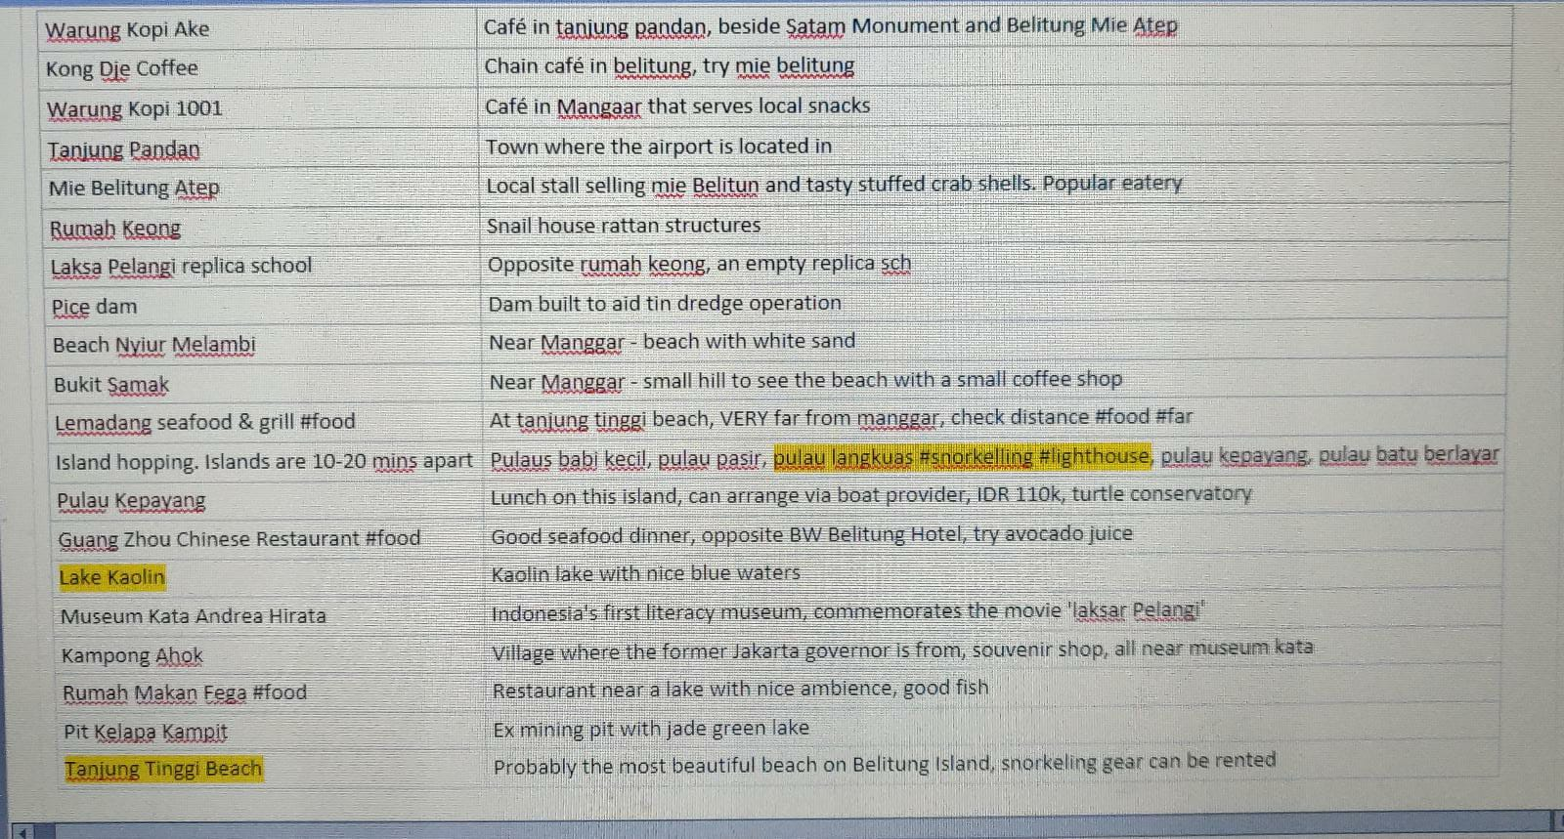

**ACTIVITIES:**

Massage

Snorkeling

Food -

1. Belitong Timpo Duluk (MUST GO: CNA recom*) - dinner (gangan, fish soup, otak-otak etc)
2. [Warung Kopi Kong Djie](https://helloechi.wordpress.com/2018/12/08/where-to-eat-in-belitung-island/)
3. [Dapur Sakato](https://helloechi.wordpress.com/2018/12/08/where-to-eat-in-belitung-island/) - Belitung specialties like Nasi rendang, fish and chicken curry, seafood
4. Batu Garuda - Situated in seashore and beachfront, seafood
5. MIE BELITUNG YAMIEN NYONG CHOI - Chinese food: Bak Chor Mee

Kayaking

1. [Eco Beach Tent](https://www.ecobeachtent.com/water)

**ITINERARY**

|  |  |  |  |
| --- | --- | --- | --- |
| **DAY** | **PLACE** | **DESCRIPTION** | **COST** |
| 1 (23/9) WED | SG - TJQ (Flight)  HOTEL: Grand Hatika Hotel | 745 - 1145AM SG - TJQ (flight)  2.00PM: Reach hotel, check in BW Suite Belitung  2PM - 6PM chill, street food and book tours | 229.20/pax  $ 57/night |
| 2 (24/9) THU | ACTIVITY  HOTEL: Grand Hatika Hotel | Have fun | $ 57/night |
| 3 (25/9) FRI | ACTIVITY  HOTEL: BW Suites Belitung | 10AM Check out of Grand Hatiika Hotel :  11AM Reach hotel, check in BW Suite Belitung  11AM Onwards - Have fun | $23/night |
| 4 (26/9) SAT | HOTEL: BW Suites Belitung | Have fun | $23/night |
| 5 (27/9) SUN | TJQ - SIN (Flight) | 4.30PM Check out and go airport  6.20PM - 12.45AM TJQ - SIN (Flight) | $23/night |

|  |  |
| --- | --- |
| **Warung kopi Ake** | **Café in Tanjung pandan, beside Satam monument and belitung mie atep** |
| **Kong Djie Coffee** | **Chain café in belitung, try the mie belitung there** |
| **Warung kopi 1001** | **café in Mangaar that serves local snacks** |
| **Tanjung pandan** | **town where the airport is located in** |
| **mie belitung atep** | **local store selling mie belitung and taste stuffed crab shells. Popular eatery** |
| **Rumah keong** | **small house rattan structures in the shape of a conch** |
| **laskar pelangi replica school** | **opposite rumah keong, an empty replica sch** |
| **pice dam** | **dam built to aid tin dredge operation** |
| **beach Nyiur melambi** | **near manggar - beach with white sand** |
| **bukit samak** | **near manggar - small hill to see the beach with a small coffee shop** |
| **lemadang seafood and grill #food** | **at tanjung tinggi beach, VERY far from manggar, check distance** |
| **island hopping, islands are 20-30 mins apart** | **pulau babi kecil, pulau pasir, pulau langkuas #snorkelling, lighthouse** |
| **more islands** | **pulau kepayang, pulau batu berlayer** |
| **pulau kepayang** | **lunch on this island, can arrange via boat provider, IDR 110k, turtle conservatory** |
| **Guang Zhou Chinese Restaurant** | **good seafood dinner, opposite BW Belitung Hotel, try avocado juice** |
| **Lake Kaolin** | **Kaolin lake with nice blue waters** |
| **Museum Kata Andrea Hirata** | **Commemorates the movie 'Laksar Pelangi' which made the place famous** |
| **Kampung Ahok** | **village where the former Jakarta governor is from, souvenir shop, near museum** |
| **rumah makan fega** | **restaurant near a lake with nice ambience, good fish** |
| **Pit Kelapa Kampit** | **ex mining pit with jade green lake** |
| **tanjung tinggi beach** | **probably the most beautiful beach on Belitung island. Snorkeling gear can be rented** |